JetBlue BG November Promo Storefront AB test result Update as of 2017-12-06:

After resetting the configuration ID on Nov 24th, the test finished in 7 days by Nov 30th for the promo period. The Test Storefront drove a +8% lift in Revenue per Visitor over the Control Storefront. However, neither ATS nor Conversion reached the statistical significance.

1. The Revenue per Visitor of the Test Storefront was **+8% higher** than the Control Storefront.
2. The conversion rate of the Test Storefront was **-1% lower** than that of the Control Storefront
3. The ATS of the Test Storefront was **+11% higher** than that of the Control Storefront

You can find the report here,

<https://data.points.com/#/views/JetBlue_Oct25-Nov30Promo2017_Storefront_ABtestafterreset/Story>

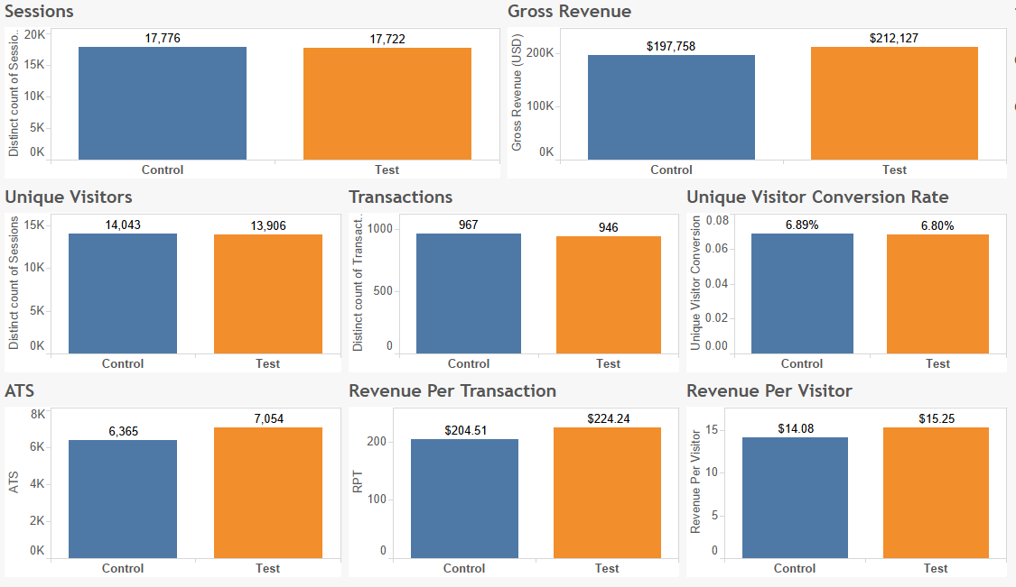

The entire Storefront test during promo ran from October 25th and November 30th for 36 days,

1. The Revenue per Visitor of the Test Storefront was **+5%** higher than the Control Storefront
2. The conversion rate of the Test Storefront was **+1% higher** than that of the Control Storefront
3. The ATS of the Test Storefront was **+4% higher** than that of the Control Storefront
4. Neither ATS nor Conversion reached statistical significance